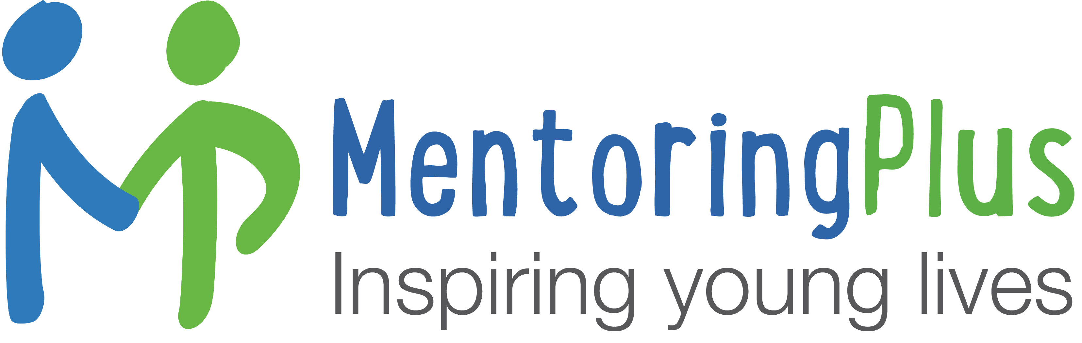

MENTORING PLUS BATH AND NORTH EAST SOMERSET LTD

Job Description

Job Title Mentoring Services Practitioner

Primary Purpose of Job To deliver safe, engaging mentoring services for a cohort of young people in need of support aged 7-25, implementing referral, risk and needs assessments, supporting adult mentors and contributing to multi-agency support for mentees and their families.

Responsible to Head of Mentoring Services

Responsible for Young people, volunteer mentors, freelance mentors

Contract Permanent PAYE, c.30 hours per week, termtime-plus (41 weeks per year).

Compensation From £14.00 per hour depending upon experience (FTE c.£27,800) plus pension and Employee Assistance Plan.

Main Duties

Working with young people facing significant challenges

- Manage a diverse cohort of young people aged 7-21 facing significant challenges from across B&NES to benefit from mentoring
*(Our cohort age ranges extend to 25 for young adults with special educational needs. Mentees aged 7-16 make up the greatest part of this cohort.)

- Assess each young person’s needs and risks with their input, matching and supporting their involvement with a volunteer or professional mentor according to individual needs and funding available

- Engage with parents / carers regularly in the best interests of the child, identifying needs, advocating for support and referring onto appropriate services as required

- Collaborate with referrers and other professionals involved to ensure best possible outcomes for your cohort, including advocating for and contributing to Team Around the Child / Family meetings, where appropriate

- Contribute to and lead Early Help Assessments, Thrive Assessments and Education Health Care Plan processes where appropriate

- Support responses, escalation, implementation and recording of safeguarding processes with support from the designated safeguarding leads

Supporting adult mentors

- Engage, support and inspire adult mentors to ensure they feel confident and equipped, building positive relationships with mentors to maximise mentor retention and word of mouth recruitment

- Supervise adult volunteers monthly, offering insights and techniques, ensuring mentoring is being delivered safely and appropriately and maintaining accurate records of supervisions

- Contribute to regular mentor training (usually 3 x yearly at weekends, for which TOIL is taken)

- Contribute to regular communications with mentors regarding further training, mentoring activity ideas, policy updates etc

Record keeping and impact reporting

- Maintain accurate and constantly updated casework information for each young person using our secure online database

- Support the team with project administration, including uploading referrals, confirming funding availability, finalising delivery contracts and liaising with referrers

- Report termly / quarterly (depending on project requirements) on each young person’s outcomes, with evidence, to enable both individual and cohort-wide impact reporting back to referring organisations.

General responsibilities

- Promote the values and ethos of Mentoring Plus at all times
- Understand and carry out the policies and procedures of Mentoring Plus as detailed in the Staff Handbook, with a particular emphasis on child safeguarding
- Undertake, share and follow risk assessments on activities as required
- Promote and encourage the participation and empowerment of young people
- Attend any internal meetings and to represent Mentoring Plus at any external meetings as required
- Support fundraising and volunteer recruitment events and communications on a regular basis (including outside normal office hours, for which TOIL is taken)
- Undertake any other duties within the scope of the role.
______________________________________

Person Specification

Qualification / Experience

- Relevant professional training or experience in youth work, education, health, social work or youth counselling / psychotherapy

- Direct relevant experience supporting young people in a similar setting

- Experience of engaging and motivating children or young people as individuals and in groups

Knowledge

- A working knowledge of the needs and concerns of children and young people, and an understanding of the issues that impact on young people who experience a range of different risk factors, minoritisation and vulnerabilities

- An understanding of the role of community organisations in delivering and influencing educational and wellbeing provision

- A good working knowledge of using MS office applications, databases and standard office technologies

Skills and Abilities

- Effective written and oral communication skills

- Confidence co-working with and influencing adults as well as young people, including advocating for families and respectfully challenging other professionals

- Ability to deal effectively with conflict and to handle sensitive issues with compassion, tact and respect

- Ability to prioritise and manage time and resources

- Ability to work on own initiative and as part of a team

- An active commitment to anti-discriminatory practice and the empowerment of young people

- Ability to effectively negotiate and work collaboratively with statutory and voluntary sector agencies

Other

- A willingness to work irregular and flexible hours from time to time to ensure the effective delivery of projects
- Full UK driving licence, daily access to a car with business insurance, and a willingness to visit and transport young people across Bath & NE Somerset as required to enable their engagement with the organisation.

